Systematic Analysis of non-verbal cue requirements and design of the Social Interaction Assistant

From Research Question 1, it is certain that there is no analysis on the needs of the visually impaired and the blind community about their needs during social interactions. Though rsearch supports the need for social interactions, no efforts have been taken towards determining the specific necessities that this community has. In order to identify the unmet needs of the visually impaired community, two focus groups consisting primarily of people who are blind, as well as disability specialists and parents of students with visual impairment and blindness where coducted[1]. Members of these focus groups who were blind or visually impaired were encouraged to speak freely about their challenges in coping with daily living. During these focus groups, the participants agreed on many issues as being important problems. However, one particular problem - that of engaging freely with their sighted counterparts - was highlighted as a particularly important problem that was not being addressed by technology specialists[2].

As an example of the type of social disconnect that people who are visually impaired face, consider a simple form of nonverbal communication: glancing at a watch to signal that it is time to wrap up a meeting. The sighted participants might respond to such a glance automatically, without consciously realizing that this visual information is not accessible to a participant who is blind. Similarly, a sighted person asking a question in a group will use gaze direction and eye contact to indicate to whom the question is directed. Without access to this visual cue, people who are blind might be left wondering whether the question was directed to-wards them. They can answer immediately (at the risk of feeling foolish if the question was not directed at them) or they can wait to see if anyone else answers (and risk being thought of as rather slow witted).

While various other examples were cited by individuals during these focus group studies, the inability to access non-verbal cues were considered of highest priority. In this chapter, we introduce a self-report survey that was conducted based on the focus group study results that highlight the various non-verbal cues that are considered important from the perspective of the user population. Further, with the non-verbal cue priority list determine, the design of a platform that can be used for extracting and delivering these non-verbal cues is presented.

# Requirements for a Social Interaction Assistant

Based on the discussions conducted through the two focus groups, a list of needs was complied that characterized social needs often experienced by people with visual impairments. In doing so, two important aspects of social interaction were identified. These included

1. Access to the non-verbal cues of others during social interactions, and
2. How one is perceived by others during social interactions.

These needs correlated with the psychology studies conducted by Jindal-Snape with children who were visually impaired.

## Access to Non-Verbal Cues

Access to the non-verbal cues of others during a social interaction is something that sighted people take for granted. Non-verbal cues such as eye contact, hand gestures, and body posture play very important roles in social communication. As an important ﬁrst step in the design of our Social Interaction Assistant, we decided to develop a better understanding of the most important non-verbal cues that we need to convey to a person who is blind or visually impaired.

## How One is Perceived by Others

Although people who are blind cannot visually perceive their own appearance and demeanor during social interactions, members of our focus groups indicated that understanding how others perceived them was important. For example, assistive technology that makes the user stand out were rejected. “Don’t make me look like a Martian” was a sentiment that was shared by most of the attendees. This sentiment makes it important that assistive technologies be extremely discreet. Ideally, assistive devices should allow a person who is blind or visually impaired to interact with sighted peers without those peers even being aware of their disability, or their assistive device.

Another cause of social isolation for people who are blind are distracting stereotypic body mannerisms which can increase the social divide as introduced earlier in the Related Works Section XXX. For example, a person who is blind might rock back and forth during a conversation without being fully aware of how this is being perceived by sighted people. Training can make people who are blind more aware of the social norms, expectations, and needs of sighted people. Assistive technologies could also play a role in helping individuals who are blind recognize, learn, and practice body mannerisms that are considered socially appropriate.

# Essential Requirements

As a ﬁrst step toward the development of a Social Interaction Assistant, we used our focus group results to identify and enumerate the following list of needs for information that is not always accessible by people who are blind, as they engage in social interactions:

1. Knowing how many people are standing in front you, and where each person is standing.

2. Knowing where a person is directing his/her attention.

3. Knowing the identities of the people standing in front of you.

4. Knowing something about the appearance of the people standing in front of you.

5. Knowing whether the physical appearance of a person who you know has changed since the last time you encountered him/her.

6. Knowing the facial expressions of the person standing in front of you.

7. Knowing the hand gestures and body motions of the person standing in front of you.

8. Knowing whether your personal mannerisms do not ﬁt the behavioral norms and expectations of the sighted people with whom you will be interacting.

## Online Survey

We conducted a web-based survey in order to validate the list of needs that we identiﬁed from our focus groups, and to help establish the relative importance for each of these needs. This survey was anonymously completed by 27 people, of whom 16 were blind, 9 had low vision, and 2 were sighted specialists in the area of visual impairment. The online survey consisted of eight questions that corresponded to the previously identiﬁed list of needs. Respondents answered each question using a ﬁve-point Likert scale:

(1) Strongly disagree,

(2) Disagree,

(3) Neutral,

(4) Agree, and

(5) Strongly agree.

Table 1 shows the eight questions, sorted by descending importance, as indicated by the survey respondents (the question numbers correspond to the need listed in the previous section).

|  |  |  |
| --- | --- | --- |
| Need | The Question | Mean Score |
| 8. | I would like to know if any of my personal mannerisms might interfere with my social interactions with others. | 4.5 |
| 6. | I would like to know what facial expressions others are displaying while I am interacting with them. | 4.4 |
| 3. | When I am standing in a group of people, I would like to know the names of the people around me. | 4.3 |
| 7. | I would like to know what gestures or other body motions people are using while I am interacting with them. | 4.2 |
| 1. | When I am standing in a group of people, I would like to know how many people there are, and where each person is. | 4.1 |
| 2. | When I am standing in a group of people, I would like to know which way each person is facing, and which way they are looking. | 4.0 |
| 5. | I would like to know if the appearance of others has changed (such as the addition of glasses or a new hair-do) since I last saw them. | 3.5 |
| 4. | When I am communicating with other people, I would like to know what others look like. | 3.4 |

Table 1: Results of the online survey

The histogram of responses (Fig. 1) from the online survey reveals the importance levels of the various needs. The responses to question 8 suggest that the respondents are highly concerned about how they are perceived by their sighted peers. The responses to questions 3, 6, and 7 suggest that respondents would like to know the identities, facial expressions and body gestures of the people with whom they are communicating. The responses to questions 4 and 5 indicate that there was a wide variation in respondents’ interest in (4) knowing the physical appearance of people with whom they are communicating and (5) knowing about changes in the physical appearance of people with whom they are communicating. Many respondents indicated moderate, little, or no interest in either of these areas.

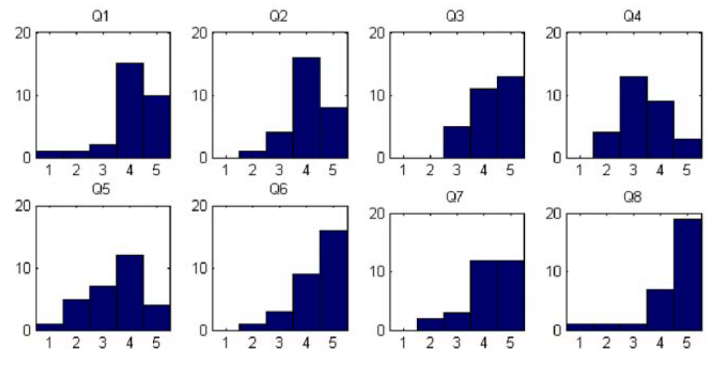

Figure XXX: Histogram of online survey responses

# Alternative Sensing Platforms for a Social Interaction Assistant

Having determined the requirements for a Social Interaction Assistant, we next concentrated on a potential platform for the device. We observed that four important criteria had to be taken into account: (1) the device must be unobtrusive and socially acceptable; (2) the device must be lightweight and compact for easy everyday use; (3) the device should be wearable, so users have their hands free; and (4) the device should allow the user to control the direction of the wearable device unobtrusively. Based on these considerations, we investigated three different conceptual approaches, including:

## Concept 1:

A wearable video camera in a clip-on device, and a small audio emitter device that could be worn on the ear without obstructing normal hearing. Both of these devices would be connected to a compact computing element such as an Ultra-mobile PC (UMPC) (Fig. 2).

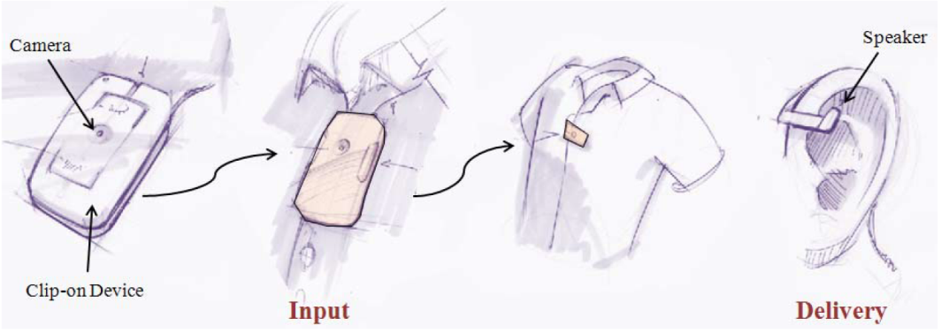

Figure XXX: A clip on camera and small speaker

## Concept 2:

A tiny, ear-mounted video camera and sound emitter (inspired by Bluetooth headsets) mounted on a small device that communicates with a UMPC (Fig. 3).

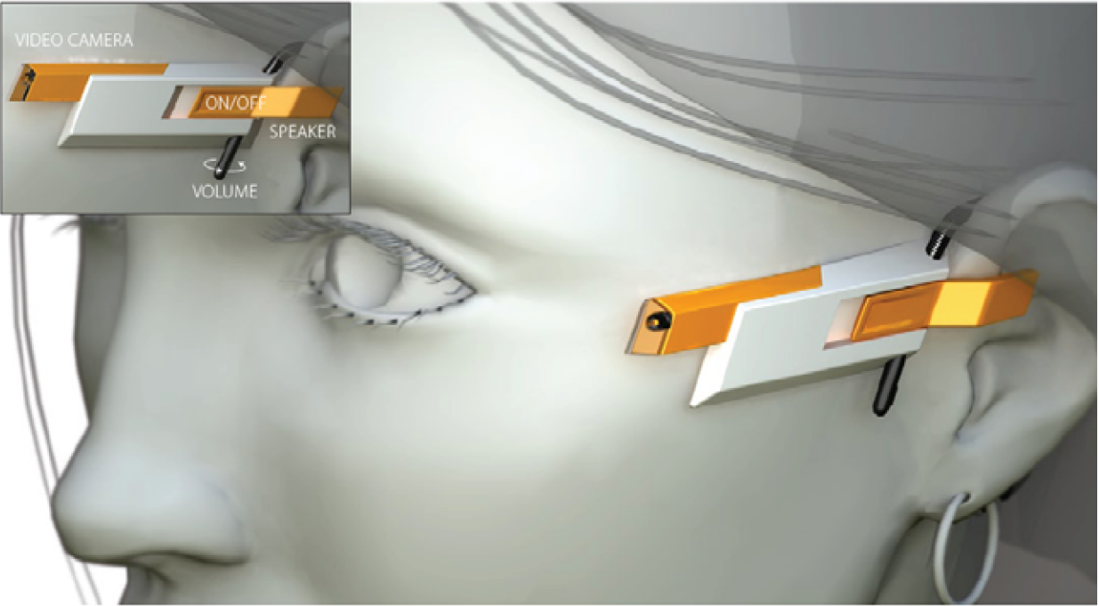

Figure XXX: A ear-mounted video camera and speaker

## Concept 3:

A tiny video camera and a sound emitter mounted unobtrusively in a pair of glasses - both of which are attached to a UMPC (Fig. 4).

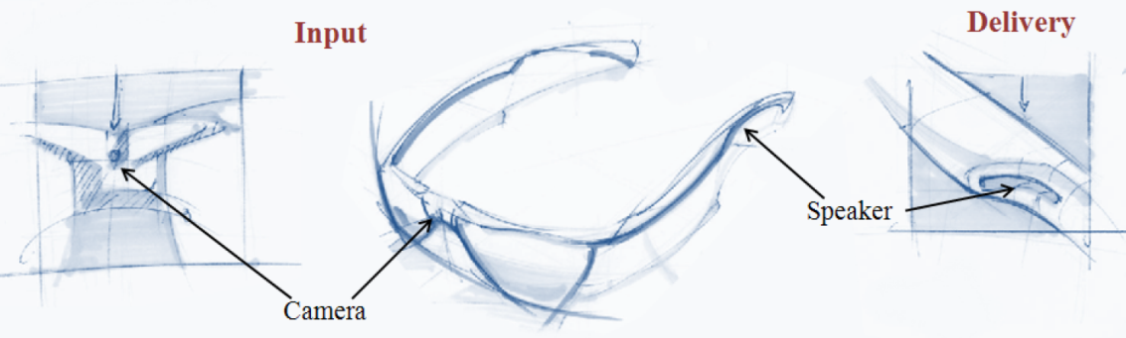

Figure XXX: A tiny video camera and speaker on a pair of glasses.

# Social Interaction Assistant:

Having analyzed the requirements and considering the various components of the sensing and delivery technology, we resorted to Concept 3 and incorporated the important aspects of egocentric and exocentric sensing into the prototype system.

## System Architecture

The system level architecture of the proposed social interaction assistant is shown in the Figure 1. The sensor suite consists of: (1) a visual sensor (1.4 Megapixel camera), (2) a motion sensor (± 12g accelerometer), and (3) a 5-button clicker, which serves as a user interface. The social interaction assistant software (implemented on a Windows Operating System PDA) uses these sensors to collect information about the various social and behavioral mannerisms of the user and participants in the vicinity of the user. Interpretations of the social interactions generated by custom algorithms are communicated to the user through an actuator suite, consisting of: (1) a haptic belt and (2) a set of ear phones. The haptic belt encodes information in the form of vibrotactile cues, while the ear phones provide short audio cues.

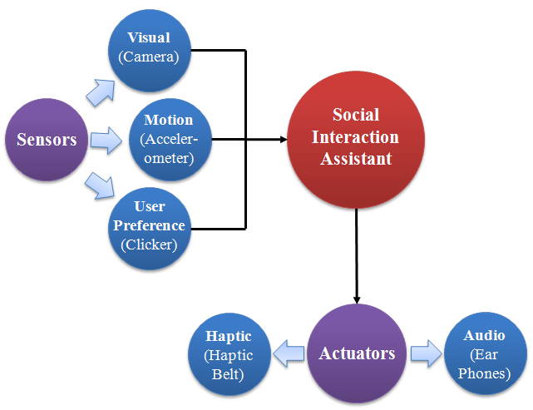

System level architecture of the Social Interaction Assistant

## Prototype System:

Figure 2 shows the implementation of the proposed Social Interaction Assistant. A tiny video camera is placed unobtrusively on a pair of glasses, and a tiny state-of-the-art accelerometer is placed unobtrusively in a hat, and is used to monitor the user’s body mannerisms – particularly those related to head movement. (Most communicative gestures are encoded in movements of head and the most widely occurring and problematic stereotypic body mannerisms are done with the head.) The accelerometer operates on a coin battery that allows for uninterrupted operation for over 4 hours. The user uses the 5-button clicker to control what types of information are delivered by the system. The haptic belt can be worn under the clothing, and the earphones are worn discretely under their hat. Thus, the proposed design of the assistive technology is (1) wearable, (2) portable, (3) unobtrusive, (4) self and other sensing, and (5) can be worn by the user for extended periods of time.

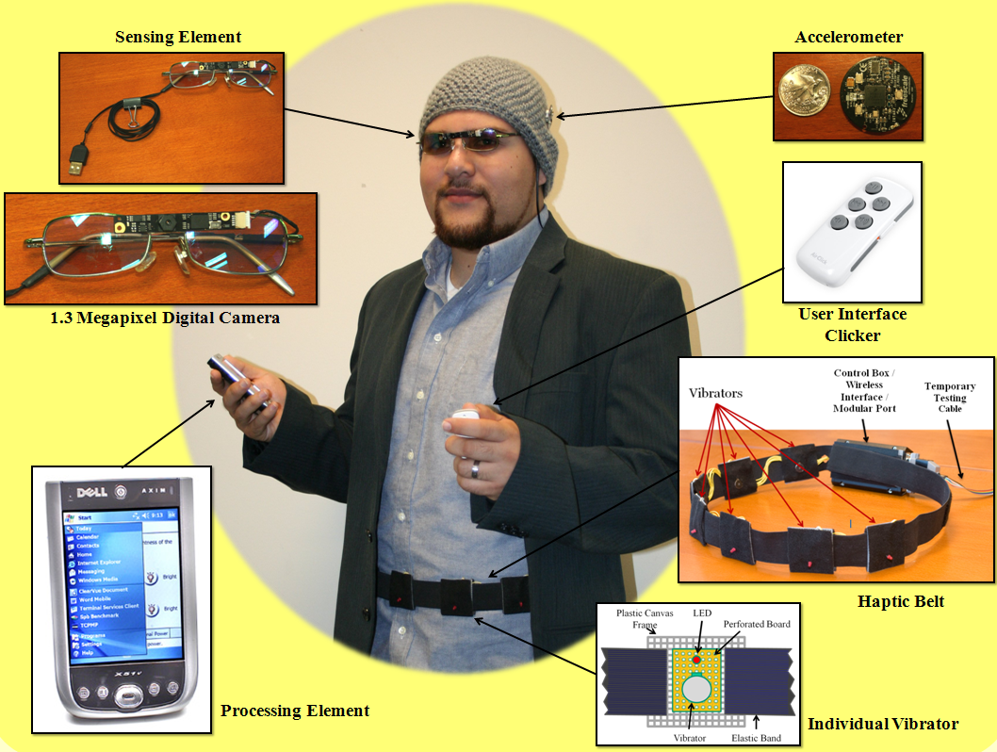

Figure 2: the implementation of the Social Interaction Assistant

1. In order to understand the assistive technology requirements of people who are blind, we conducted two focus group studies (one in Tempe, Arizona USA - 9 participants, and another in Tucson, Arizona USA - 11 participants) which included:

   1. students and adult professionals who are blind,

   2. parents of individuals who are blind

   3. professionals who work in the area of blindness and visual impairments.

   There was unanimous agreement among participants that a technology that would help people with visual impairment to recognize people or hear them described would signiﬁcantly enhance their social life.
2. To quote some candidates opinion about face recognition technology in a social setting:

   • “It would be nice to walk into a room and immediately get to know who are all in front of me before they start a conversation”.

   One young man said, “It would be great to walk into a bar and identify beautiful women”.